HTML front with FLASK as backend server and below screen you can see HTML page where user can enter review and select desired algorithm and in below screen you can see Flask server started and you can start this server by double click on ‘run.bat’ file

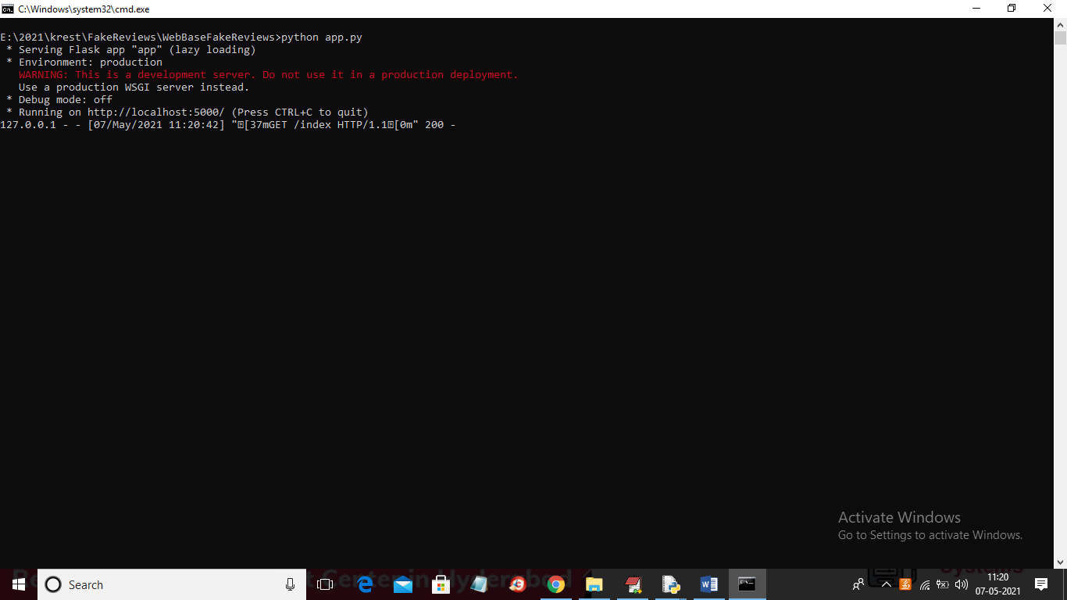

In above screen Flask Server started and now open browser and enter URL as <http://localhost:5000/index> and then press enter key to get below page



In above screen user can enter review and select one algorithm from give 4 algorithms and in below screen you can see list of algorithms

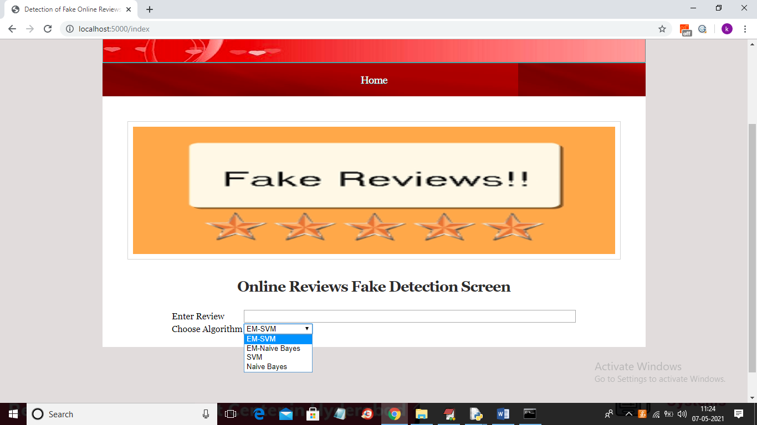



In above screen I entered some review and then select algorithm as ‘EM-SVM’ and now press Submit button to get below result

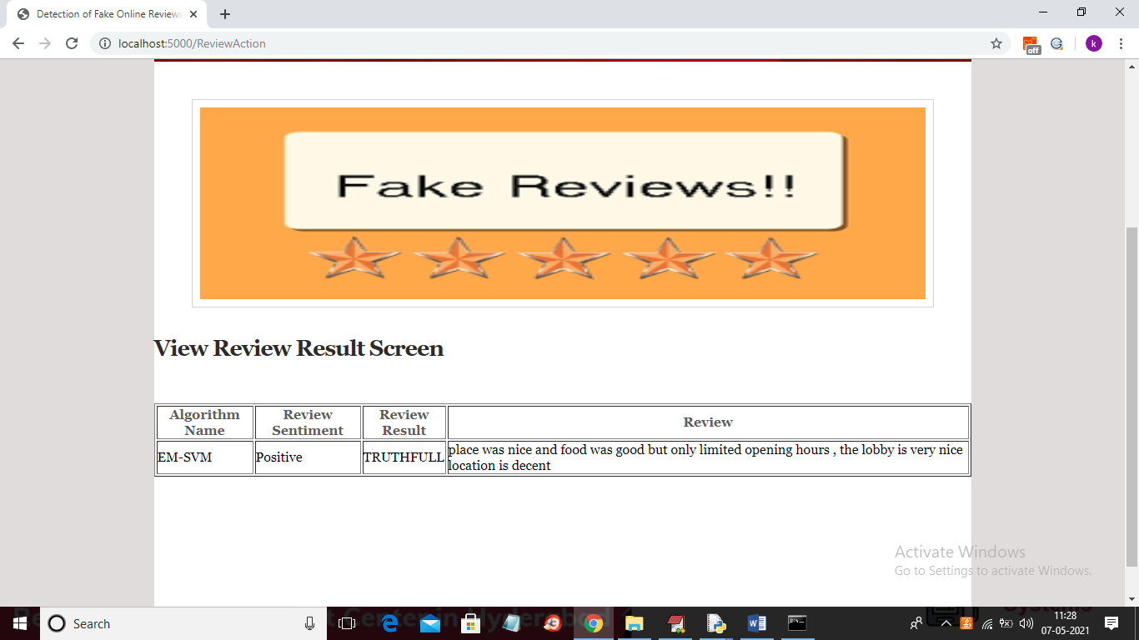

In above screen we can see review result is ‘TruthFull’ and sentiment as ‘Positive’. Now test with other review

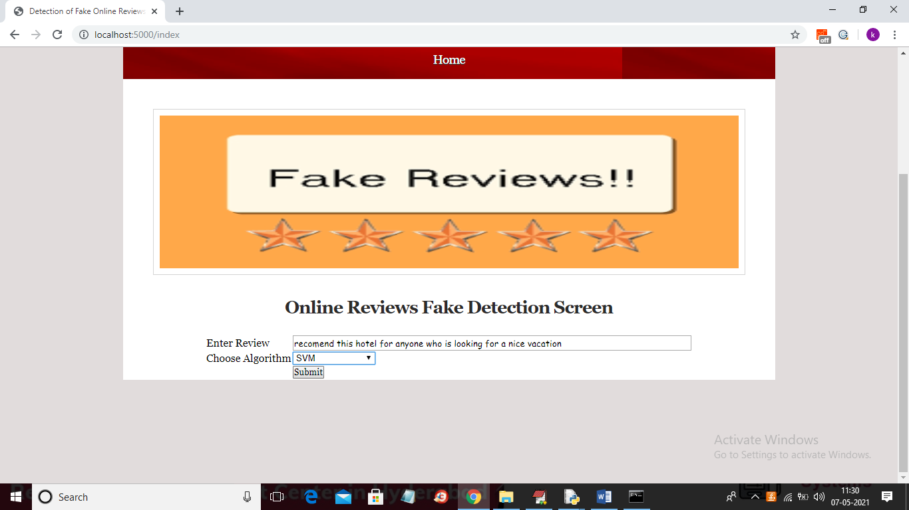

For above review will get below result

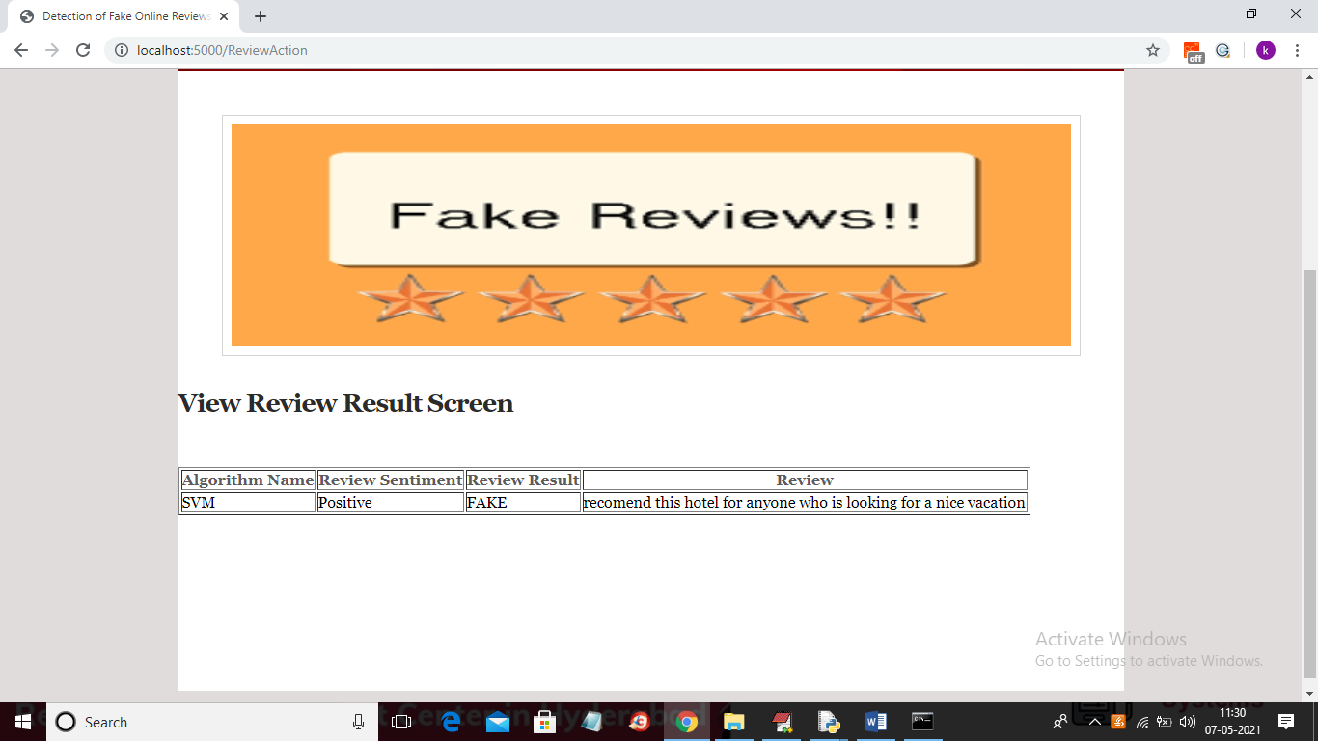

In above screen review is positive but more words are matching with fake reviews so result detected as FAKE.

In above screen you can see user entering review in HTML page and in backend we put all computation process. We saved all models and when we start Flask server then all models will be loaded and do prediction.

When firs time when Flask server starts at that time only all models will be loaded and when we send POST request then application will run only prediction code.

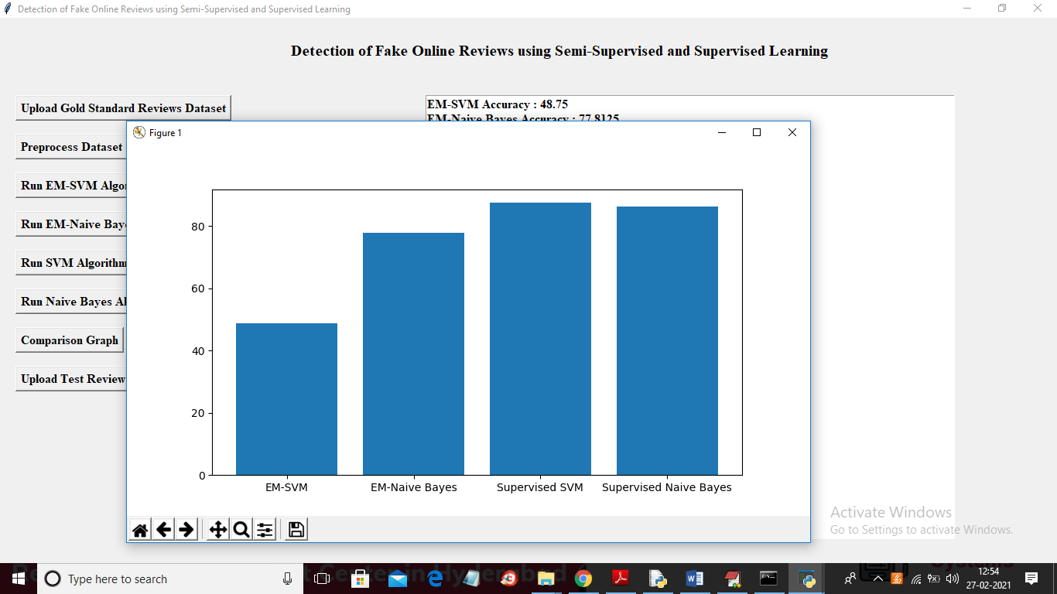

when we calculate sentiment then all positive sentiment score will be greater than >= 0.05 and negative sentiment score will be <= - 0.05 and whatever comes between those two values will be consider as NEUTRAL

Normally all ML application will use 80-20 percent for train and test data and we if want we can add “random-state” value to method to perform random sampling